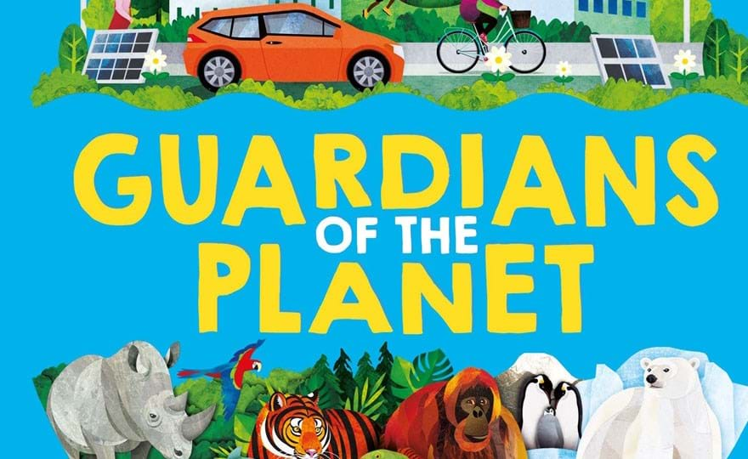
W/C 3rd June 2024 Letter Sound Ss
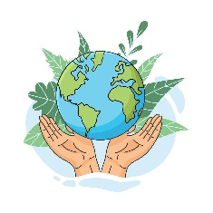
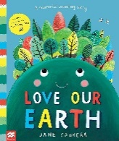
The Earth – Our Planet – The Universe Why is our Planet so special – What is it made up from Water, Land and Vegetation Who Lives on it – Plants, Humans and Animals Love our Earth – counting story Sponsor Sports Day Sheets sent home
Craft – The Earth for the wall using different blues and greens that the children have found at home to recycle.
Begin Father’s Day Craft
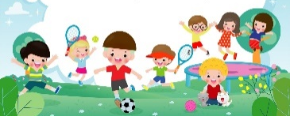
W/C 10th June 2024 Letter Sound Tt
Sponsored Sports Week
Looking at some of the other Planets in our Solar System Comparing the sizes and colours – why we can’t live on them
Zooming to the moon
‘I can Save the Earth’, Little Monster learns to reduce, reuse and recycle
Designing our own planets – Finish off F.D Craft

W/C 17th June 2024 Letter Sound Uu
Why we need to look after our beautiful Earth
Caterpillars to Butterflies – Awe and Wonder Using our new books with child friendly illustrations to explain and talk about what everyone needs to try to do to help it remain healthy and beautiful –
How we become ‘Guardians of the Planet’ Turn the Tap off – Switch the lights off
The World came to My Place Today - George Saves the World
Michael Recycle – Litterbug Doug
Junk Models – Caterpillar Craft

W/C 24th June 2024 Letter Sound Vv
Endangered Animals – look after the areas that they live
(Jungle, Grasslands, Forest, the Artic and the Sea)
We do not want them to be just a memory in a book/tablet or in a zoo/wildlife park
What is happening to the places where they live? Chopping down trees and forests - Continue with looking at our beautiful Earth using our stories and books with child friendly
illustrations to explain and talk about what everyone needs to try to do to help it remain healthy and beautiful.
Jonathan Jungle – Monday 24th morning and afternoon sessions
Sandwich Making
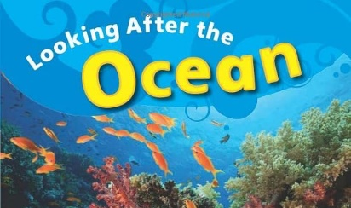
Free Craft Choices

W/C 1st July 2024 Letter Sound Ww
Introduction to the seaside/ocean – what we find there
Harbours, Cliffs and Beaches (sand, stones and pebbles)
Children to bring in pictures of seaside places they have visited
and their experiences – The Beach Café role-play
What we like to do there, sandcastles, rock pools and swimming
Construction – the biggest sandcastle Re-cap on clean beaches/keeping our sea free of plastics
Sharks and Sea creatures & hand print crabs

W/C 8th July 2024 Letter Sound Xx
What we might find at the beach – Environment recap
Examining objects (patterns/colours) listening to shells
Getting Lost and safety at the seaside (lifeboats and helicopters)
Craft – Rock pool plates

W/C 15th July 2024 Letter Sound Yy & Zz
Pirates and Mermaids
A variety of songs and stories
Digging for treasure
Making maps and Jazzy Eye Patches
Friday 19th Graduation and after school Jellytots Jamboree 4.30 – 6pm
WE RETURN ON MONDAY 2ND SEPTEMBER, HAPPY HOLIDAYS

