

FARMS

WEEKLY GUIDE

APRIL – MAY 2024

W/C 15TH April 2024 Letter Sound Mm

Introduction to what we might find on a farm

Learning new words Arable - Crop - Wheat, Barley, Oats, Corn, Hay and Straw

Rows, Lines and Patterns

Oats Beans and Barley Grow - Scarecrow Song - Farm Cat

‘M is for Macdonald’ ☺

CT – Collage pictures (oats, beans and barley)

TADPOLES – Life cycles (if we have not missed them)

W/C 22nd April 2024 Letter Sound Nn

What crops are made into, looking at different foods, playing food games.

MC900237221[1]CT – Pastel drawing of fruit (real fruit to look at/ examine)

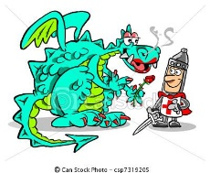 Tractor Wheel Printing

St. Georges Day – Flag making (St. George and the Dragon)

MC900441866[1]Earth Day – Looking after our Planet

The Key Children’s Sunflower Competition – Which one will be the tallest?

Monkeys, Tigers, Zebras, Pandas and Crocodiles

MC900383272[1]

W/C 29th April 2024 Letter Sound Oo

Planting – what we need to make things grow?

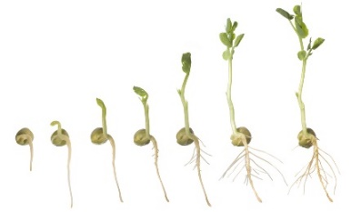Sequencing (sizing – growth) Watching the Bean shoot/grow on the window

The children to decorate their pot and plant their own Sun flower seeds

CT – Decorating Pots and Planting

Group Scarecrow Making (this is a first but we think it will be fun, it will involve lots of language, imagination and creativity, you will no doubt spot it in the garden when finished☺)

Extended Learning – Looking at information books of how things

change and grow

**Visit to Lower Shaw Farm Tuesday 30th morning/afternoon sessions**

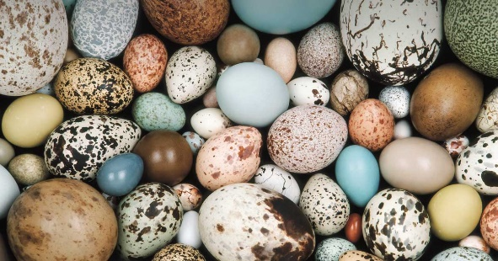

**EGGS**

**WEEKLY GUIDE**

**APRIL – MAY 2024**

**W/C 7th May 2024 (4 days)** Letter Sound Pp

Looking at eggs – what lays them, the shapes and colours etc.

Looking on the computer and in books to find out facts and fiction!

Finding the strange eggs outside (another lovely way to extend imagination and langugae)

Finding the giant egg – postitional language

Egg Carriers – Thinking about how we can construct something to protect the Eggs to keep them safe.

Humpty Dumpty – Feelings

Changing the words to the rhyme to sit Humpty on different things.

**W/C 13th May 2024**  Letter Sound Qq

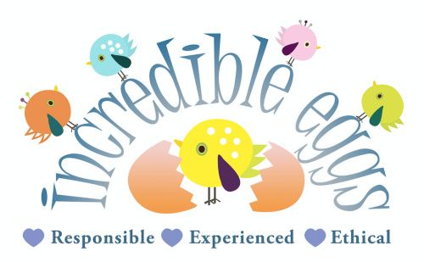Continue from last week and the exciting arrival of our unhatched chicks

Finding out what we have to do to help them hatch safely and

then how to look after them, what they will need to grow,

being gentle and kind.

Creating chick pictures, with feathers, tissue, wool etc

**W/C 20th May 2024** Letter Sound Rr

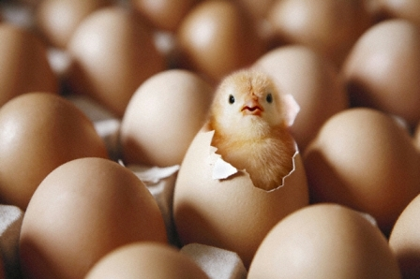Extend from last week with lots of opportunites to hold

and stroke the chics

Take Chicks to Andrea on Thursday 23rd

Continue with chick pictures, with feathers, tissue, wool etc.

Jellytots Cake Sale Friday 24th

Happy Half Term

We are back on 3rdJune

