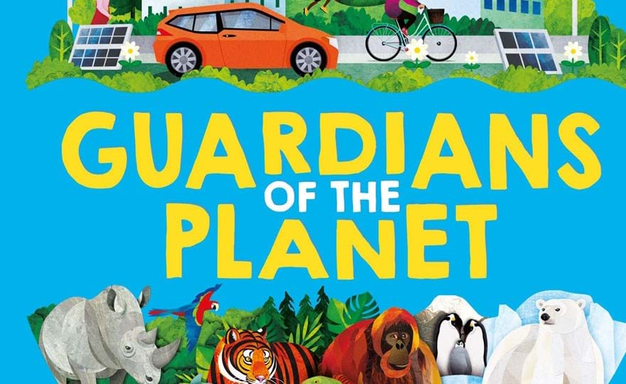
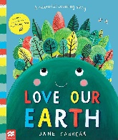
W/C 1ST June 2026 Letter Sound Rr The Earth – Our Planet – The Universe Why is our Planet so special. What is it made up from Water Land and Vegetation Who Lives on it – Plants, Humans and Animals Love our Earth – counting story Sponsor Sports Day Sheets sent home Create Earth Picture with Blue – Green and White

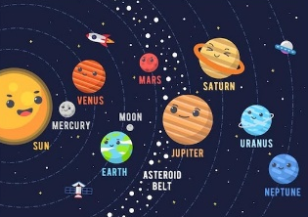
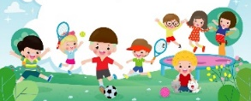
W/C 8th June 2026 Letter Sound Ss Sponsored Sports Week
Looking at some of the other Planets in our Solar System Comparing the sizes and colours – why we can’t live on them
Zooming to the moon
‘I can Save the Earth’, Little Monster learns to reduce, reuse and recycle
Life-cycle Caterpillars arrive Krazy Kanga’s Wed 10th 2.15pm
Craft – Begin Father’s Day Craft
Designing our own planets
Sandwich Making

W/C 15th June 2026 Letter Sound Tt
Why we need to look after our beautiful Earth
Caterpillars to Butterflies – Awe and Wonder Using our new books with child friendly illustrations to explain and talk about what everyone needs to try to do, to help it remain healthy and beautiful –
How we become ‘Guardians of the Planet’ Turn the Tap off – Switch the lights off
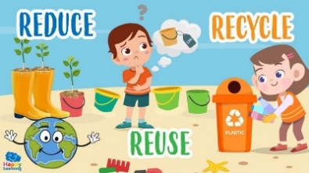
Reuse, Reduce, Recycle –
Visit from the Recycling Truck TBC
The World came to My Place Today - George Saves the World
Michael Recycle – Litterbug Doug
Finish off F.D Craft

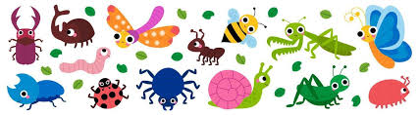
W/C 22nd June 2026 Letter Sound Uu
Mini Beasts homes and habitats
Selection of stories and rhymes
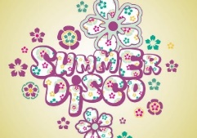
Mini Beast Models – Mini Beast Craft
Vegetable and Fruit snack bugs
Summer Disco Thursday 25th June 4.30 – 5.30
Krazy Kanga’s Fri 26th 10.45

W/C 29th June 2026 Letter Sound Vv
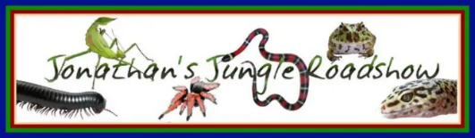
Summer Trip Monday 29th
Continue with our mini beast theme with a visit from
Jonathans Jungle Roadshow Wed 1st July (am/pm)
Mini Beast Models – Mini Beast Craft

W/C 6th July 2026 Looking after the oceans Letter Sound Ww
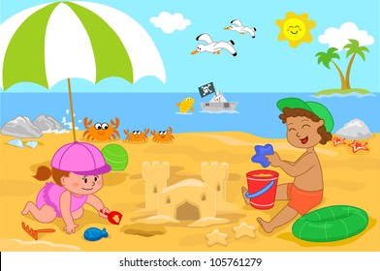
Thinking about the Seaside & Ocean – what we find there
Harbours, Cliffs and Beaches (sand, stones and pebbles)
The Beach Café role-play
What we like to do there, sandcastles, rock pools and swimming
Construction – the biggest sandcastle
Re-cap on clean beaches/keeping our sea free of plastics
CT - Sharks and Sea creatures & hand print crabs
Krazy Kanga’s TBC (Wed 8th 2.15?)

W/C 13th July 2026 Letter Sound Ww Yy Zz
What we might find at the beach – Environment recap
Examining objects (patterns/colours) listening to shells
Getting Lost and safety at the seaside (lifeboats and helicopters) Dinky Ponies Wed 15th 10-11.30 (Open to all) Pirates and Mermaids - A variety of songs and stories
Digging for treasure
Graduation and Jamboree Thursday 16th 4.30 – 6pm
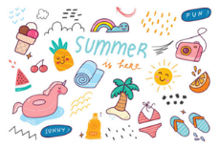
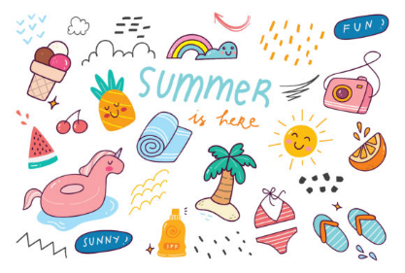
HAPPY SUMMER HOLIDAYS
We are back on Tuesday 1st September

